4. TECHNICAL REPORT OF THE PROGRAMME
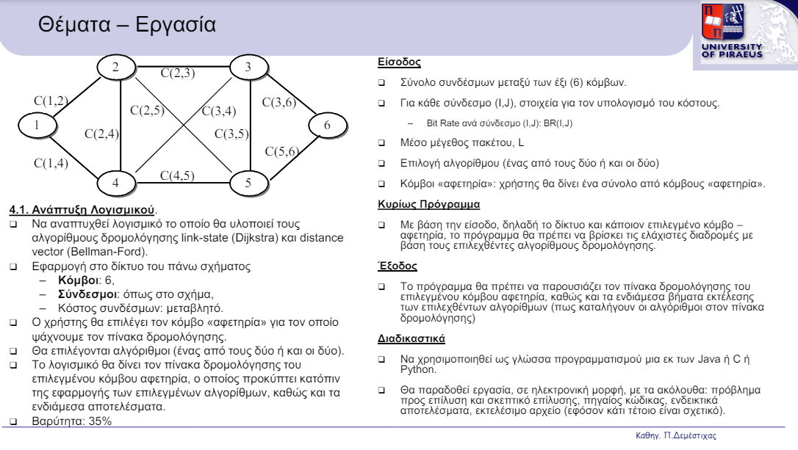
DESCRIPTION

- INPUT
The program asks the user to enter the bit rate for each link (i, j), the average packet size L, the choice of how the routing table will be calculated and the starting node. In addition, the program generates the Graph shown in the pronunciation.
Average Packet Length L:
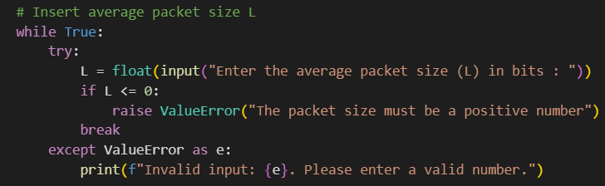
The program asks the user to enter this value while performing validity checks. The value must be a positive number. Otherwise, the error message is displayed. In addition, a validity check is performed if the user enters a character while expecting a number. Then it displays a message accordingly and the user is asked to enter the size again.
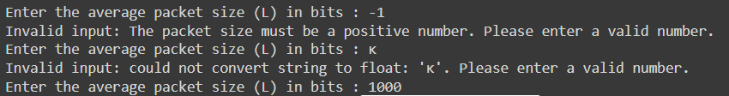

Insert cost for each edge (i, j):
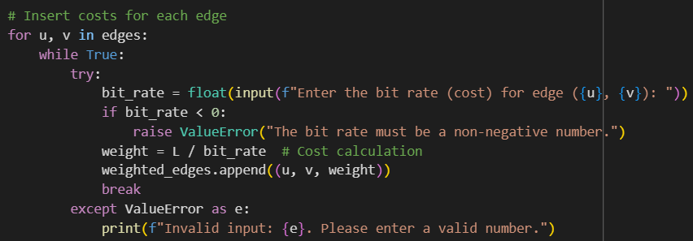
The program asks the user to enter the bit rate for each node. This value must always be non-negative. If the user enters a non-negative value, an error message is displayed, and the user is asked to enter it again for that node. The same happens if the user enters a character instead of a number.
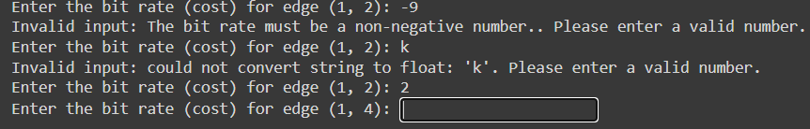
After a correct value is entered in bit_rate then the cost for this node is calculated (weight = L / bit_rate) and stored appropriately.

Algorithm and starting Node Choice
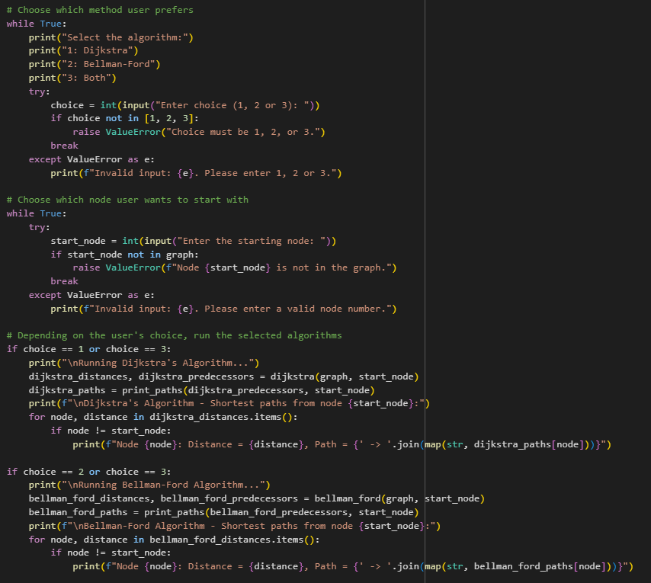
A selection menu appears on the user's console. Through this, the user chooses which algorithm to run. He can run Dijkstra's algorithm, Bellman-Ford's algorithm, or both. To enter his choice he must select a number from 1 to 3. If he enters anything else an error message is displayed.
After the user has chosen which algorithm he wants, the user is then prompted in the same way as before to enter the starting point, where a value from 1 to 6 must be entered.
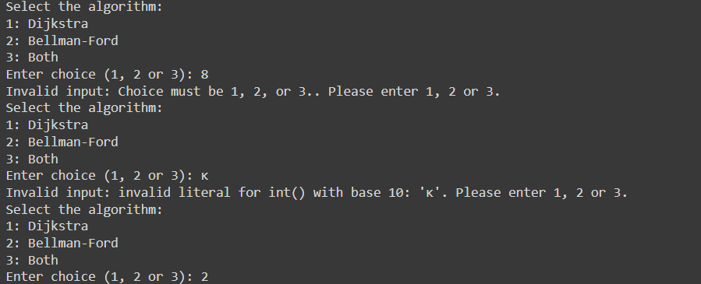
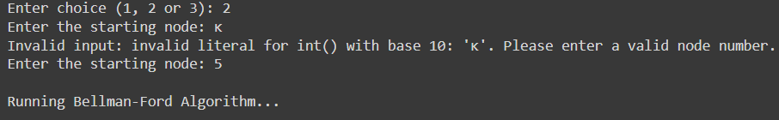

Total Liaisons
The program itself introduces a set of nodes at the beginning and initializes a list where the transition costs from node i to j will be stored. Then, the create_graph function is called (after the user enters bit rate for each node and packet size L) where a Graph is created with the costs lying between the edges.
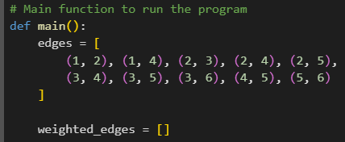
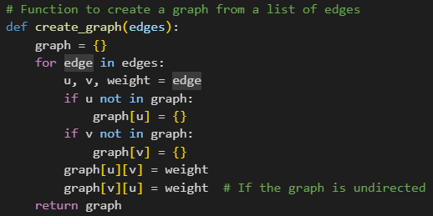

Main
In the introduction of how to calculate the minimum costs, there are 3 options available: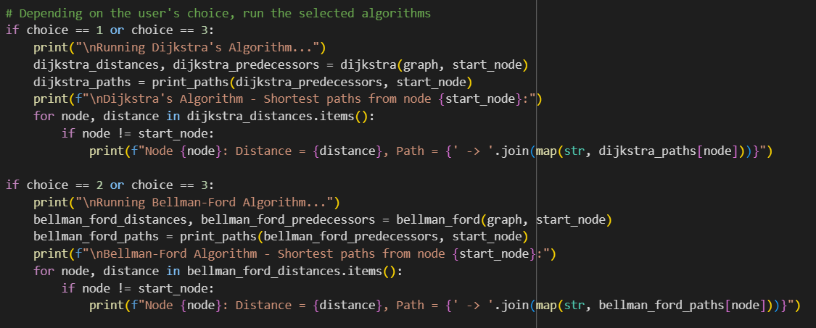
1.DIJKSTRA: Dijkstra’s algorithm is used to calculate routing table.
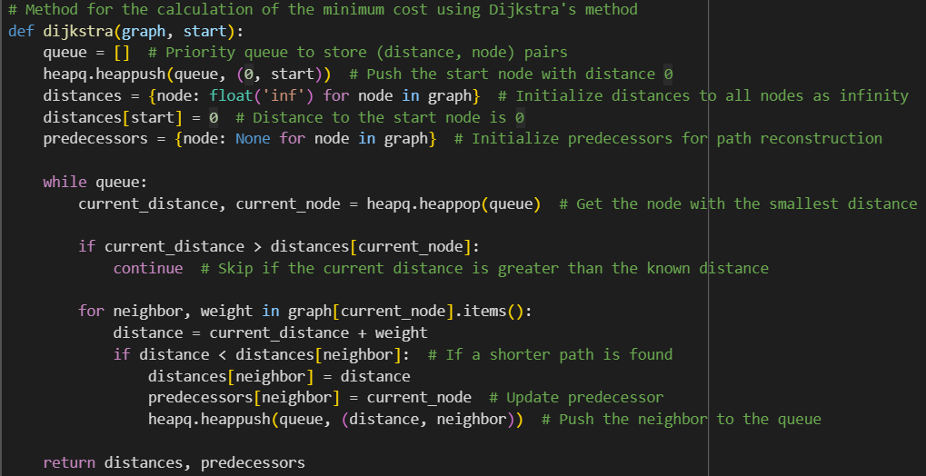
2.BELLMAN-FORD: Βellman-Ford algorithm is used to find routing table.
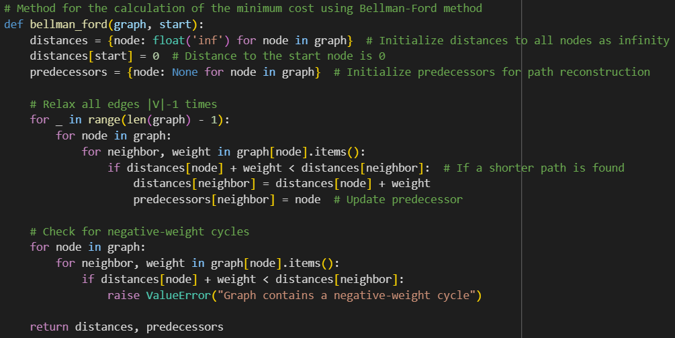
3.ΒOTH: both algorithms are used to calculate routing table.

OUTPUT
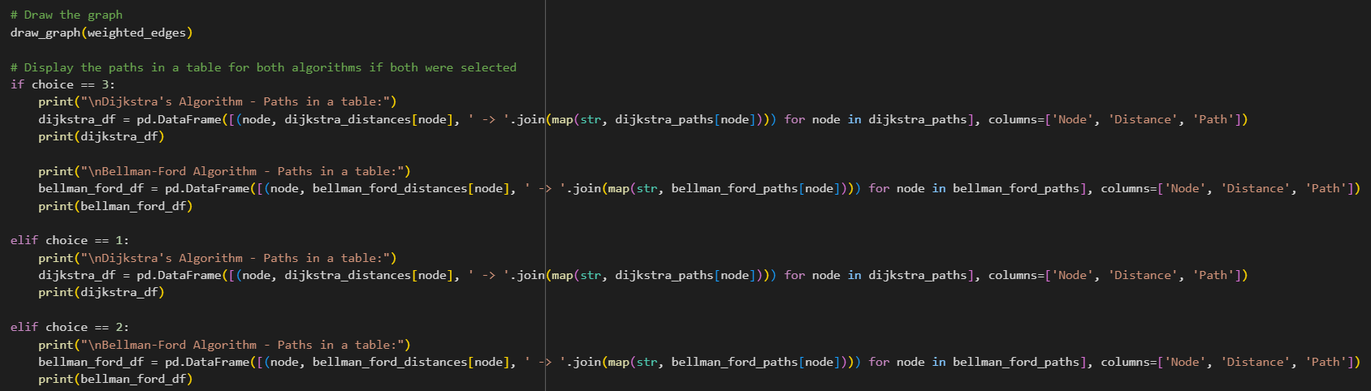
Για την εμφάνιση των μονοπατιών, καλείται μια μέθοδος που εμφανίζει τα κόστη και τα μονοπάτια για κάθε κόμβο.
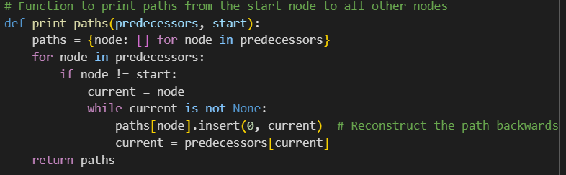
Επιπλέον καλείται η μέθοδος draw_graph όπου σχεδιάζει τον Γράφο
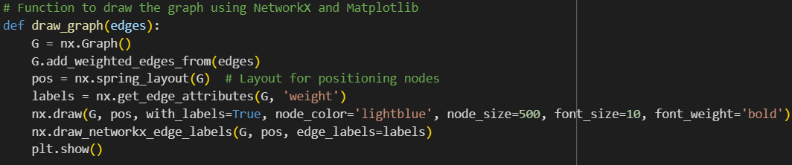

SAMPLE OUTPUT
